CSA 0976 Java Programming

Name: C.Manjunath reddy

Reg no: 192011373

Assignment 4

1.Code:

import java.io.\*;

class FileStats

{

public static void main(String[] args)

{

String fileName = "File1.txt";

int wordCount = 0;

int charCount = 0;

int lineCount = 0;

try (BufferedReader br = new BufferedReader(new FileReader(fileName)))

{

String line;

while ((line = br.readLine()) != null)

{

lineCount++;

String[] words = line.split("\\s+");

wordCount += words.length;

charCount += line.length();

}

}

catch (IOException e)

{

e.printStackTrace();

}

System.out.println("Word count: " + wordCount);

System.out.println("Character count: " + charCount);

System.out.println("Line count: " + lineCount);

}

}

Output:

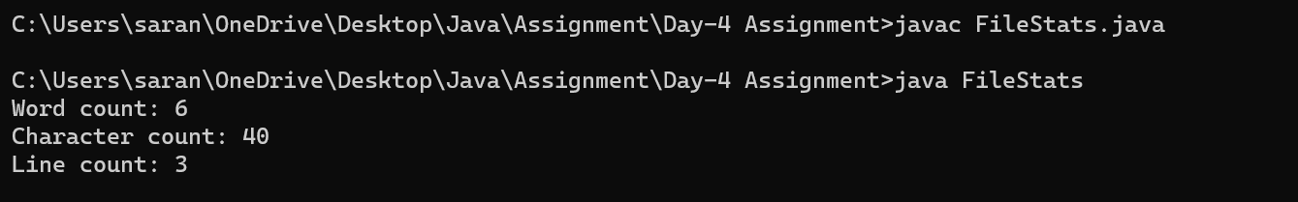

2.Code:

import java.io.\*;

class Customer

{

private int accountNo;

private String accName;

private int balance;

public Customer(int accountNo, String accName, int balance)

{

this.accountNo = accountNo;

this.accName = accName;

this.balance = balance;

}

public synchronized void deposit(int amount)

{

balance += amount;

System.out.println("Amount " + amount + " deposited. New balance is " + balance);

notify();

}

public synchronized void withdraw(int amount)

{

if (balance < amount)

{

System.out.println("Insufficient balance. Waiting for deposit...");

try

{

wait();

}

catch (InterruptedException e)

{

e.printStackTrace();

}

}

balance -= amount;

System.out.println("Amount " + amount + " withdrawn. New balance is " + balance);

}

}

class Main

{

public static void main(String[] args)

{

int i=12345;

String s="Saran";

int amount=1000;

Customer customer = new Customer(i,s,amount);

System.out.println("Account holder name :"+s);

System.out.println("Account balance :"+amount);

Thread withdrawThread = new Thread(() -> {customer.withdraw(1100);});

Thread depositThread = new Thread(() -> {customer.deposit(200);});

withdrawThread.start();

depositThread.start();

}

}

Output:

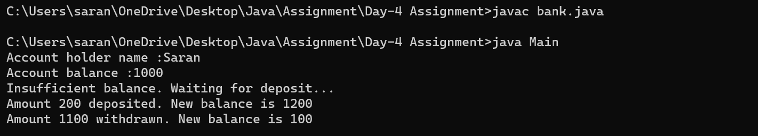

3.Code:

import java.io.\*;

import java.util.\*;

class FizzBuzz

{

public static void main(String arg[])

{

int i;

String a[]=new String[1000];

Scanner s=new Scanner(System.in);

System.out.print("Enter N value :");

i=s.nextInt();

for(int j=1;j<=i;j++)

{

if(j%3==0 && j%5==0)

{

a[j-1]="FizzBuzz";

}

else if(j%3==0)

{

a[j]="Fizz";

}

else if(j%5==0)

{

a[j]="Buzz";

}

else

{

a[j]=Integer.toString(j);

}

}

System.out.println("List :");

for(int j=1;j<=i;j++)

{

System.out.println(a[j]);

}

}

}

Output:

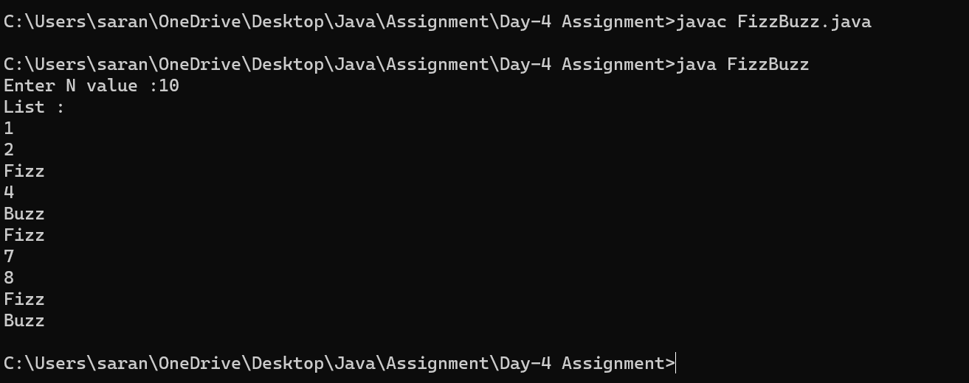

4.Code:

import java.io.\*;

import java.util.\*;

class StringShifts

{

public static boolean canBecomeGoal(String s, String goal)

{

if (s.length() != goal.length())

{

return false;

}

for (int i = 0; i < s.length(); i++)

{

if (s.equals(goal))

{

return true;

}

s = s.substring(1) + s.charAt(0);

}

return false;

}

public static void main(String[] args)

{

String s1;

String goal;

Scanner s=new Scanner(System.in);

System.out.print("S :");

s1=s.nextLine();

System.out.print("goal :");

goal=s.nextLine();

System.out.println(canBecomeGoal(s1, goal)); // false

}

}

Output:

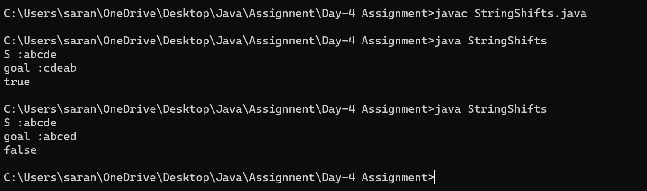

5.Code:

class PrimeExample implements Runnable

{

@Override

public void run()

{

int i, m = 20, flag = 1;

for (i = 1; i <= m; i++)

{

if (i <= 3)

{

System.out.println(i + " is prime number");

continue;

}

else

{

flag = 1;

for (int j = 2; j < i; j++)

{

if (i % j == 0)

{

flag = 0;

break;

}

}

if (flag != 1)

{

System.out.println(i + " is not prime number");

}

else

{

System.out.println(i + " is prime number");

}

}

}

}

}

class prime

{

public static void main(String args[])

{

try

{

PrimeExample p1 = new PrimeExample();

Thread t1 = new Thread(p1);

t1.start();

}

catch (Exception e)

{

System.out.println(e.getMessage());

}

}

}

Output:

